Image | 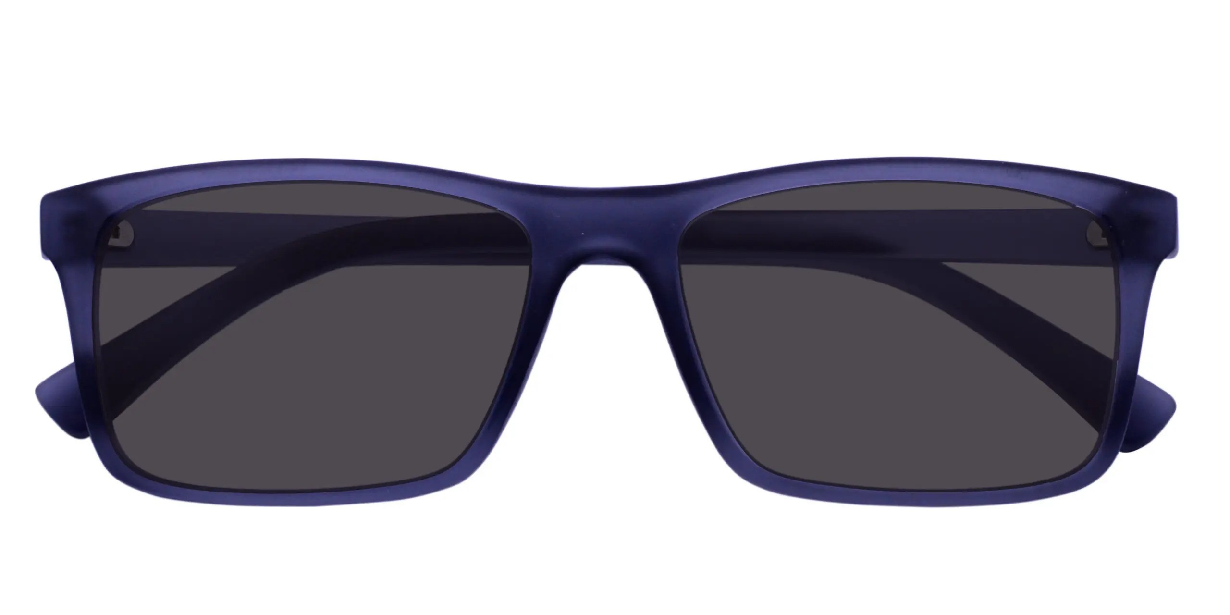
Brand | RAYBAN
Model Name | Casa p-10022
Price | RS 1000
PRODUCT DETAILS

